[Image description: This image displays official technical validation rules from the Banco Central del Uruguay (BCU) regarding the format and content of data fields for the BCF system. It details specific requirements for fields such as "fecha-instruccion," "codigo-cliente," "codigo-beneficiario," and "bajo-acuerdo-libre," defining how these must interact with variables like "instruccion-por-cuenta" and "tipo-linea." These specifications are essential for ensuring that imported Excel data complies with regulatory reporting standards for the BCU Communication 2024/159.]
[Image description: The image displays the "Errores del Proceso 2" interface, which presents a detailed table identifying specific data inconsistencies found during the file import process. Each row lists the problematic "Línea," "Columna," and "Tag," followed by a technical description of the error (such as "Dato no válido," "Dato Obligatorio," or sum discrepancies), the invalid data entered, and its corresponding instruction and reference number. This view is essential for users to identify, troubleshoot, and correct data errors in their XLS files to ensure successful compliance reporting.]
[Image description: The image displays the web browser login interface for the BCF system, accessible via the URL 192.168.2.226:8080/DynBCFTesting/com.dynbcf.wlogin. The page features a central "ACCESO" (Access) box containing fields for "Usuario / Email" (User/Email) and "Password," a "Recordarme" (Remember me) checkbox, a blue "Login" button, and an "Olvidé mi contraseña" (Forgot my password) link. This interface confirms the user has reached the correct destination to authenticate and begin using the BCF compliance system.]
[Image description: The image provides the technical specifications for the "Registro de Instrucciones" XSD file required for BCU compliance, presented as a table titled "Información a enviar." It details eleven specific data elements—such as tipo-linea, numero-instruccion, and codigo-cliente—defining their required format (e.g., Alphanumeric, Integer, Date, Boolean) and specific constraints or permitted values for each. This information is critical for users to correctly structure their Excel import files to ensure they generate compliant XML documents for the System of Centralized Submission (IDI).]
[Image description: The image displays the "Procesamientos" (Processing) dashboard of the BCF system, featuring a left-hand navigation menu and a central workspace with buttons for "Nuevo Proceso" (New Process), "Exportar XLS" (Export XLS), "Reporte" (Report), and "Seleccionar columnas" (Select Columns). The main content area contains a data table header with columns for Id, Fecha, Usuario, Imp, Mes, Archivo, Lineas, Errores, Itr Desde, Hasta, and Exp, currently showing "No se encontraron registros" (No records found). This interface serves as the primary hub for users to initiate data imports and view processing history, marked by the Dynatech logo in the lower-left corner and user account information in the top navigation bar.]
[Image description: This document, featuring the BCU Superintendencia de Servicios Financieros header, outlines specific validation rules for data fields required for the BCF system. It mandates that the sum of individual client values for "valor-nominal-cliente" and "valor-efectivo-cancelacion-cliente" must match the reported totals, and establishes that "cant-itr-sin-valor-nominal-total" is required if "valor-nominal-total" is empty, and vice versa. Additionally, it confirms that the "codigo-moneda-cancelacion" field is mandatory for proper compliance with the regulatory reporting requirements.]
[Image description: The "Procesamientos" screen displays a grid of file imports, identifying the status of each upload through indicators like "IMPOK" (green) for successful imports and "IMPERR" (red) for those containing errors. To manage these processes, users can utilize the action buttons in the top toolbar or click the XML icon located at the end of each row to generate the required compliance file for the Central Bank of Uruguay. This interface allows users to monitor processing results, identify error counts, and finalize the reporting workflow for each uploaded record.]
[Image description: The image displays the "Anexo. Tabla Tipo Valor Instrumento" (Annex. Instrument Value Type Table), which provides the official BCU coding for financial instruments used in the system. The table maps specific two- or three-letter codes—such as BGN for "BONOS EMITIDOS POR EL GOBIERNO NACIONAL," ON for "OBLIGACIONES NEGOCIABLES," and AX for "ACCIONES"—to their corresponding financial instrument descriptions. This reference is critical for users to correctly categorize instruments in the XLS import files to ensure compliance with BCU Communication 2024/159.]
[Image description: Upon accessing the system, a login screen appears featuring a button labeled "Nuevo Proceso." Clicking this button is the required action to initiate a new data import or compliance process within the BCF system.]
[Image description: The image displays a formal technical table titled with the BCU (Superintendencia de Servicios Financieros) logo, which defines the specific data fields required for the BCF system's Excel import process. It lists each field name (such as "codigo-valor-instrumento" and "valor-nominal-total"), provides a brief description of the data intended for each, and specifies the technical format (e.g., Alphanumeric, Numeric, Boolean) and whether the field is mandatory. This table is essential for users to correctly prepare their input files to ensure compliance with the central bank's communication requirements.]
[Image description: The image displays the "Procesamientos" (Processing) screen of the BCF system, which lists import operations with columns including ID, date, user, status (Imp), month, filename, line count, errors, and export status (Exp). It specifically highlights the workflow for generating the required XML file: when the "EXPOK" button is clicked in the "Exp" column for a processed file, the system automatically triggers a download of the XML file, as indicated by a red arrow pointing to the browser's download notification in the top right corner (e.g., "Comunic_2019_334_202403 (2).xml"). This visual confirms the successful generation and retrieval process of the compliant XML file required for the Banco Central del Uruguay communication.]
[Image description: The image displays the main dashboard of the BCF system, which features a table listing past import processes with columns for ID, date, user, status (IMPOK/IMPERR), period, filename, line counts, and errors. Above the table are functional buttons for "Nuevo Proceso" (New Process), "Exportar XLS" (Export XLS), "Reporte" (Report), and "Seleccionar columnas" (Select Columns). A red arrow and box in the screenshot highlight an action menu available for each process, which includes the options "Visualizar" (View) and "Anular Importación" (Cancel Import).]
[Image description: The image displays a modal dialog titled "Importar Xls Instrucciones," which is used to upload Excel files into the system for processing. It includes a standard "Choose File" button to select the document from the local machine and two primary action buttons labeled "Importar" (to execute the import) and "Cancelar" (to close the dialog without action). This interface is the critical point of interaction for users to initiate the data import process required for compliance with the Central Bank of Uruguay communication.]
[Image description: The image displays the official Banco Central del Uruguay (BCU) header followed by a section titled "Validaciones" which outlines specific rules for data entry fields within the BCF system. It details technical requirements for fields such as *tipo-linea*, *descripcion-error*, *numero-instruccion*, and *correlativo-instruccion*, specifying conditional constraints for dates, correlative numbering, and record types ("A", "B", "C", "O"). This information is critical for users to correctly prepare their Excel files for XML generation, as it defines the business logic and structural dependencies required for successful regulatory reporting.]
[Image description: The image displays the required header structure for the Excel spreadsheet used to import data into the BCF system. The first row contains the mandatory column names from A to N: tipo-linea, numero-instruccion, correlativo-instruccion, fecha-instruccion, instruccion-por-cuenta, tipo-instruccion, codigo-cliente, codigo-beneficiario, bajo-acuerdo-libre, intermediario-instruccion, tipo-codigo-instrumento, codigo-valor-instrumento, tipo-valor-instrumento, and descripcion-instrumento. These headers must be present in the user's spreadsheet to ensure successful data processing and XML generation for compliance with BCU Communication 2024/159.]
[Image description: The image displays the "Procesamientos" (Processing) screen of the BCF system, which provides an interface to manage data imports, including action buttons like "Nuevo Proceso," "Exportar XLS," "Reporte," and "Seleccionar columnas." The main data grid lists processed files with specific columns for ID, date, user, import status (e.g., "IMPERR"), period, filename, line count, and error count. Notably, the "Errores" column for the entry with ID 2 is highlighted with a red box around the value "21," indicating a specific record containing errors that require user attention.]

Cartilla de uso sistema BCF

Comunicación 2024/159

Versión 2.0
Diciembre 2024

Índice

Sistema BCF 3
Acceso 3
Pantalla Principal 4
Anexo explicación de Excel 7
Anexo Controles BCU 8

Sistema BCF

Sistema que permite importar desde planillas XLS el control y la generación de archivo XML para el cumplimiento de la Comunicación del Banco Central del Uruguay: Comunicación 2024/159

Acceso

URL: http://192.168.2.226:8080/ValoresWeb/com.valoresweb.wloginvalores (esta es la interna Dynatech)

Aparecerá pantalla para acceso en la cual deberá tener usuario (un alias) y un password.
Dicho usuario deberá tener asociado una casilla, la cual debe estar asociado a una casilla o bien con el dominio de la empresa o casilla registrada en el BCU.
El usuario estará vinculado a una empresa y ésta a la empresa que le dé el soporte, de aquí en adelante denominada “Consultora”.

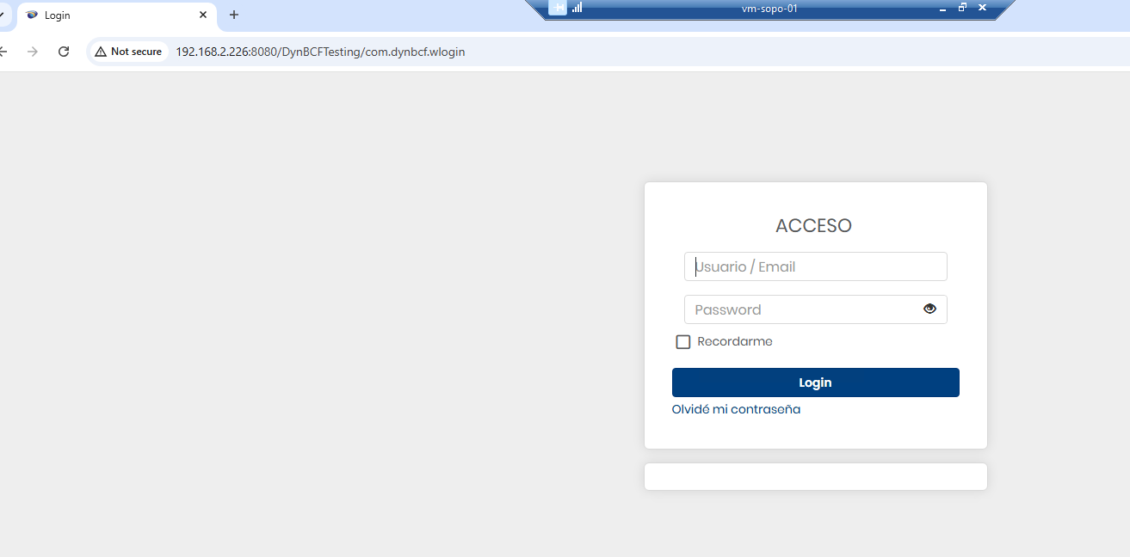

Pantalla Principal
Al momento del ingreso se presenta la siguiente pantalla,
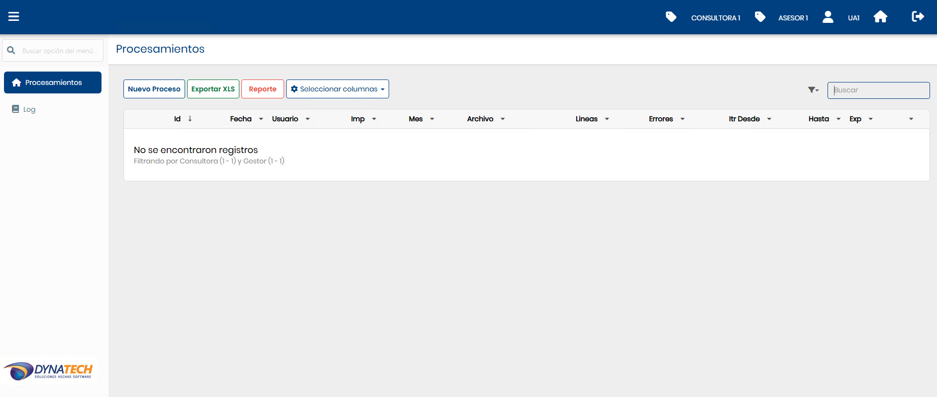
En la parte superior de la misma, observamos el usuario conectado, a que asesor/gestor/agente pertenece y a cuál consultora.
En cuanto a la funcionalidad, se pueden generar procesamientos (lectura de Excel y generación de xml).

Nuevo Proceso de importación
Al presionar  se presenta la siguiente pantalla:
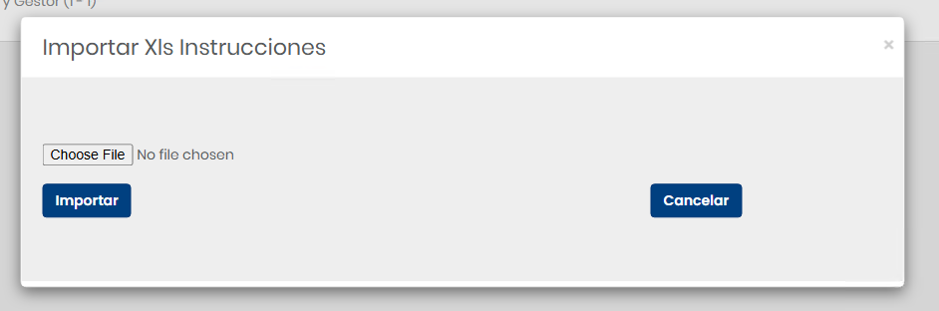
En donde se selecciona el archivo que contiene todas las instrucciones (formato fijo, ver Anexo Excel) y se da importar.

El sistema realiza controles y si encuentra errores los presenta en la grilla
De la siguiente manera:
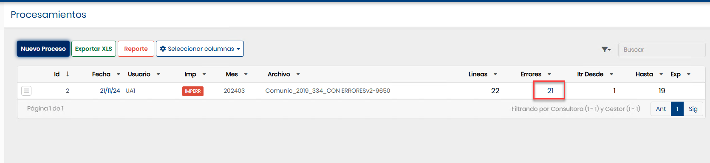
Haciendo clic en errores, se detallan los mismos, con indicación de la línea y columna del Excel con el error correspondiente, así como indicación del tag y el motivo del error. (ver Anexo Controles para detalle de los mismos)
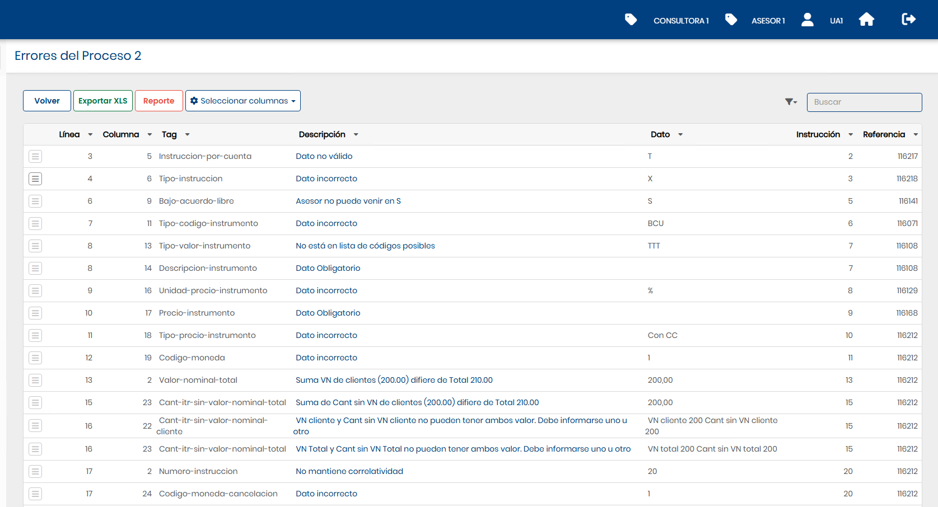

Una vez resuelto todos los errores en el Excel, se hace  y se mostrara la lectura sin errores, en ese momento se habilita botón (icono) para generar xml.
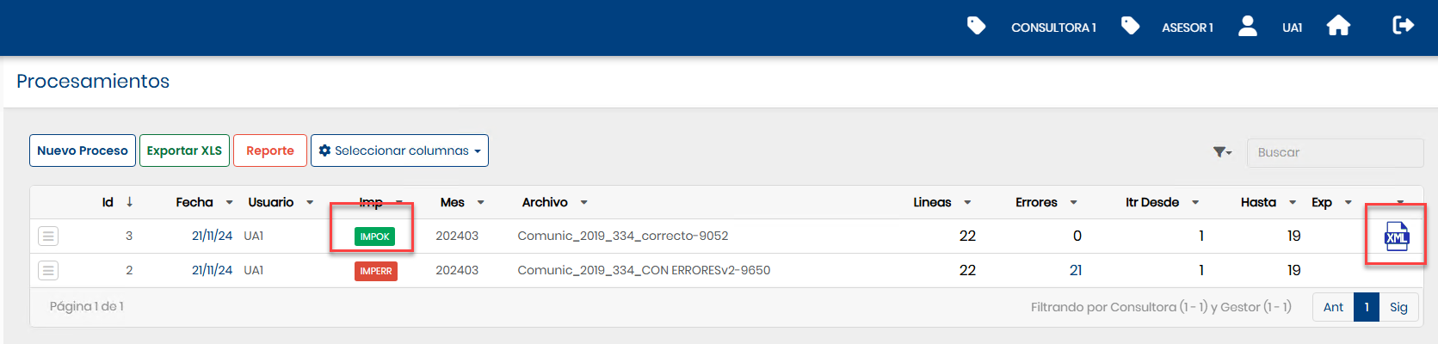
Haciendo clic en el icono del xml, se genera el archivo y lo podemos obtener en descargas, quedando envío ok.
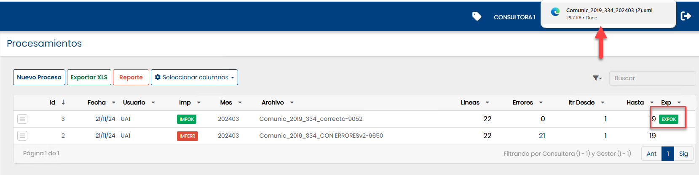
En caso de que por cualquier motivo se desee regenerar el xml, deberá eliminarse el envío e importar nuevamente el Excel, para generar nuevo XML.
Se elimina en el menú de la línea:
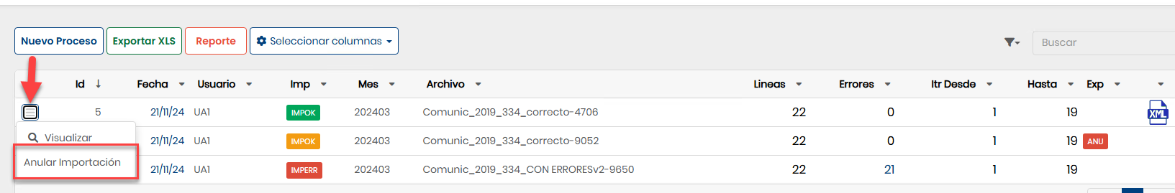

Anexo explicación de Excel

Se lee un archivo Excel predeterminado, conteniendo en la fila uno los títulos y comenzando los en la fila 2 comienzan los datos.
La estructura es la siguiente:
Columna | Elemento | Observaciones
A | tipo-línea
B | numero-instrucción
C | correlativo-instrucción
D | fecha-instrucción | No se permiten fechas a futuro  No se permiten fechas anteriores a 60 dias del comienzo del período a procesar.
E | instrucción-por-cuenta
F | tipo-instrucción
G | código-cliente
H | código-beneficiario
I | bajo-acuerdo-libre
J | intermediario-instrucción
K | tipo-código-instrumento
L | código-valor-instrumento
M | tipo-valor-instrumento
N | descripción-instrumento
O | valor-oferta-publica
P | unidad-precio-instrumento
Q | precio-instrumento
R | tipo-precio-instrumento
S | código-moneda
T | valor-nominal-cliente
U | valor-nominal-total
V | cant-itr-sin-valor-nominal-cliente
W | cant-itr-sin-valor-nominal-total
X | código-moneda-cancelación
Y | valor-efectivo-cancelación-cliente
Z | valor-efectivo-cancelación-total
AA | Observaciones
AB | Operación | Campo de esta aplicación, no esta en el formato del BCU, es opcional y sirve para referenciar el número original de la operación que genera esta línea.

Anexo Controles BCU

El sistema controla los datos incluidos en el Excel, a estos efectos se tomó como base las especificaciones técnicas emitidas por el BCU: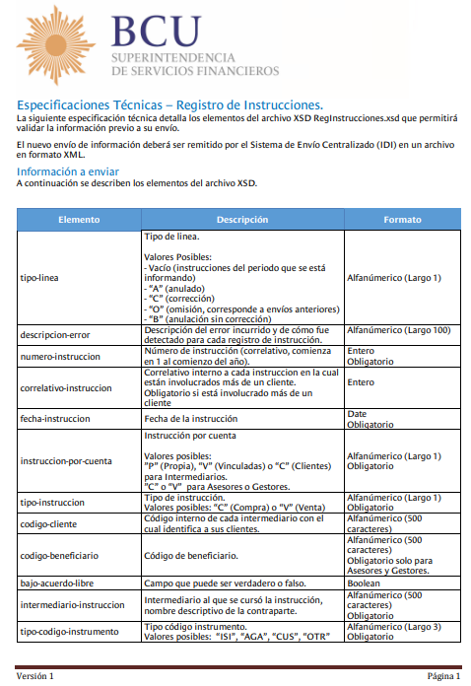
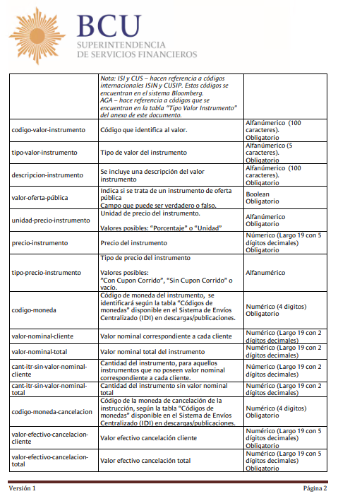

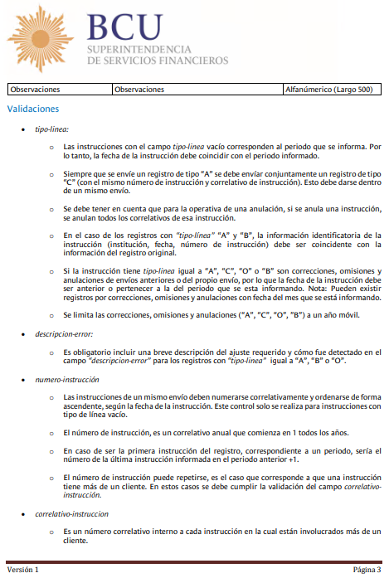

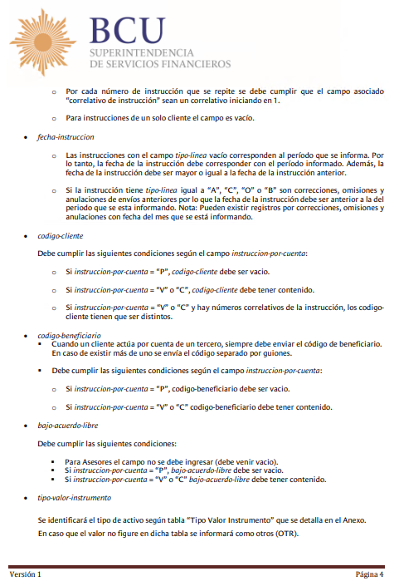
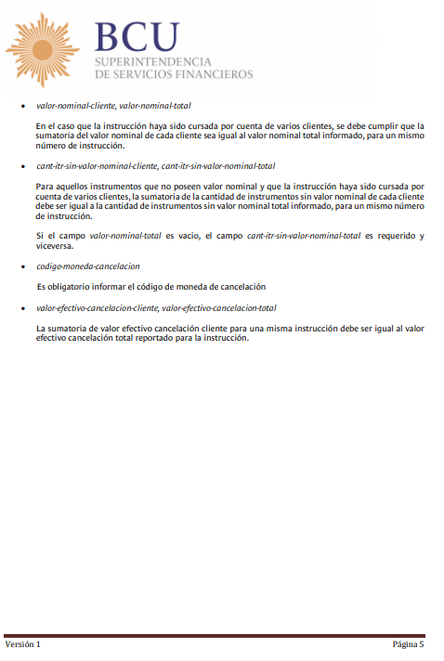
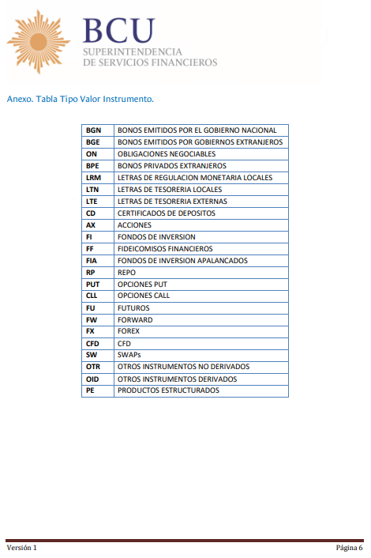

Los códigos de monedas se validan contra el código BCU, según el siguiente detalle:
Nombre | Código
DOL. AUSTRALIANO | 105
PESO ARGENTINO | 500
REAL | 1000
EURO | 1111
PESO CHILENO | 1300
DOL. NEOZELANDES | 1490
RAND SUDAFRICANO | 1620
CORONA DANESA | 1800
DOLAR USA | 2222
DOLAR CANADIENSE | 2309
LIBRA ESTERLINA | 2700
YEN | 3600
NVO.SOL PERUANO | 4000
YUAN RENMIMBI | 4150
YUAN OFF SHORE | 4155
PESO MEXICANO | 4200
FORINT HUNGARO | 4300
LIRA TURCA | 4400
CORONA NORUEGA | 4600
GUARANI | 4800
CORONA ISLANDESA | 4900
DOLAR HONG KONG | 5100
WON | 5300
RUBLO | 5400
PESO COLOMBIANO | 5500
RINGGIT MALAYO | 5600
RUPIA INDIA | 5700
CORONA SUECA | 5800
FRANCO SUIZO | 5900
BOLIVAR | 6200

